DEADLIFT ALTERNATIVES: WORK THE SAME MUSCLES, AVOID INJURIES
Deadlifts are an exercise that tend to be part of every gym-goer’s strength training regimen. That is because deadlifts are a compound movement that work to strengthen a variety of muscles all over the body like your
- Hamstrings
- Glutes
- Back
- Hips
- Core
- and to a lesser extent, the traps
Although this move is generally seen as a no-brainer when it comes to whether or not you should do it, deadlifts may not actually be for everyone.
Maybe you’ve already tried picking some heavy weights up off the floor, and it didn’t work out quite as well as you hoped. Maybe you suffer from things like
- Joint pain
- Back pain
- Mobility issues
- Or you’re recovering from an injury
And you want to get into a workout routine, but you’re worried the deadlift might put you out of commission. Perhaps, you simply just don’t like it!
Well, fear not! There are a plethora of deadlift alternatives that you can do in place of the deadlift that are just as effective at targeting one, some, or all of those muscles.
In this article, I will be sharing a few of exercises that I think are the most effective deadlift alternatives, as well as:
- Exercises that can help strengthen the same muscles the deadlift strengthens
- The benefits of exercises that don’t put as much strain on the lower back
- Exercises that can improve coordination and balance
- Exercises if mobility is an issue
- Deadlift alternatives for a variety of pains such as the back, shoulders, knees, and general joint pain
And, I will also be discussing:
- When you should involve a professional
- Tips for avoiding injury when exercising
- Deadlift alternatives – the bottom line
But, before we get started, let me introduce myself!
Hi!
I’m Igor Klibanov. I am the proud author of 7 different books on exercise and nutrition, as well as a certified personal trainer. I work primarily with clients who have health problems such as osteoporosis, joint pain, high blood pressure, and diabetes, many of whom require alternatives to popular or common exercises such as the deadlift.
So, without further ado, let’s get started with our first topic:

EXERCISES THAT STRENGTHEN THE SAME MUSCLES AS THE DEADLIFT
If you’re here, you clearly would like to replace the deadlift with other exercises due to any of the reasons I listed above. In order to do that effectively, you need to know which exercises would actually be good deadlift alternatives, by knowing which ones work the same muscles.
To recap, the main muscle groups that the deadlift works are the hamstrings, glutes and lower back.
So, those exercises would be:

GOOD MORNINGS
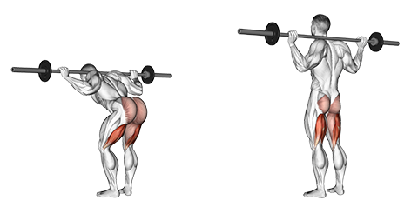
Original source: here
This exercise is done with a barbell that rests on your traps, or just behind your shoulders. With the barbell in place and standing with your feet shoulder width apart, you then hinge forward from your hips, not your waist, keeping your knees ever so slightly bent and your back flat. Stop when you either feel a stretch in your hamstrings, or when you get to about 90 degrees, and then come back into standing position.
As you may be able to tell from that description, this move works almost the entire backside of your body. That being your hamstrings, glutes, and lower back muscles. Plus, they’re really good at replicating the hip-hinging that occurs during a deadlift. I wrote a full article on good mornings here, so I won’t go into too much detail in this article.

SINGLE LEG RDLS (ROMANIAN DEADLIFTS)
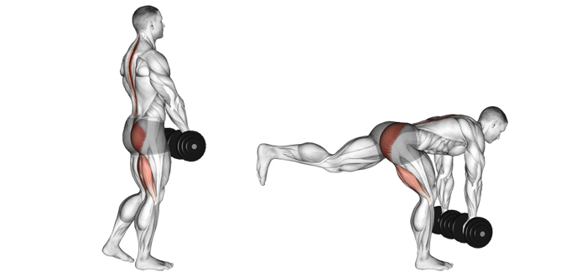
Original source: here
Similar to the popular Romanian deadlift, just done a little differently.
This exercise can be done with a dumbbell, or a kettlebell. Your starting position is standing with your feet shoulder-width apart and knees slightly bent, like with regular Romanian deadlifts. Raise a single leg off the floor. Then, keep your back arched as you hinge at the hips and lower your torso until it is almost parallel with the floor. You don’t want to go past parallel. Then, return to the starting position, and make sure you’re not pushing your hips forward when you do so.
This is a great move to replicate the resistance from the classic deadlift on your glutes, hamstrings, and entire posterior chain. These are also great if you want to keep the element of the hip-hinge seen in a traditional deadlift. And yes, I wrote an article about Romanian deadlifts as well. Here it is.

SQUATS
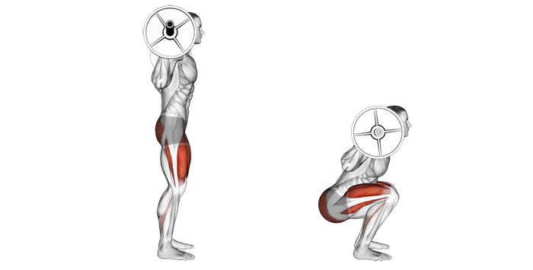
Original source: here
This move can be done with just body weight, dumbbells, or a barbell. I’ll describe how to do a barbell squat, as that is what’s most common.
First, you place the barbell behind you, resting it just above your shoulders. This should be on the muscles of your upper back. If you’re doing this at a rack then make sure to step backwards far enough away from the rack. If you’re nowhere near one, then don’t worry about that step. Then, make sure your feet are slightly wider than hip-width apart, and keep your feet flat.
When you’re ready, start moving down by bending at the hips. You’re trying to bring your butt towards your heels. Once you’ve reached as low as you can go (ideally below parallel), come back up to your starting position.
This is also a really popular move at the gym, and for good reason. It’s a great compound movement that works primarily your quads, glutes, and to a lesser extent, the hamstrings.

KETTLEBELL SWINGS
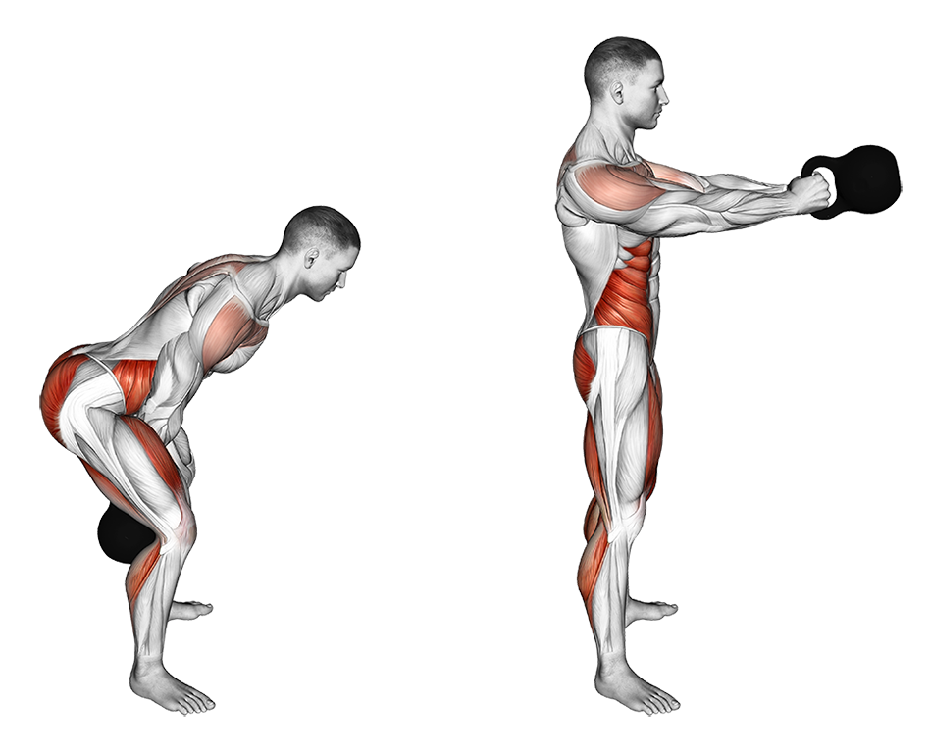
Original source: here
The kettlebell swing is done with a kettlebell, hence the name. First, lean down to pick up the kettlebell and while keeping your heels planted, push your hips back until your hands reach the handle. Then, you start your swing from behind you, in between your legs. End the swing at chest height while keeping your arms long and loose. Make sure not to push your hips forward as you reach the top, stand nice and straight. As the kettlebell starts to descend, shift your weight back into your heels and repeat. Remember to not use your arms or upper body for anything except keeping the kettlebell in your hands, as that will not help you work the desired muscles.
Kettlebell swings are a great alternative for deadlifts because they mainly target your glutes, hamstrings, and lower back muscles. These are also a fantastic exercise as part of a full body workout.

RACK PULLS
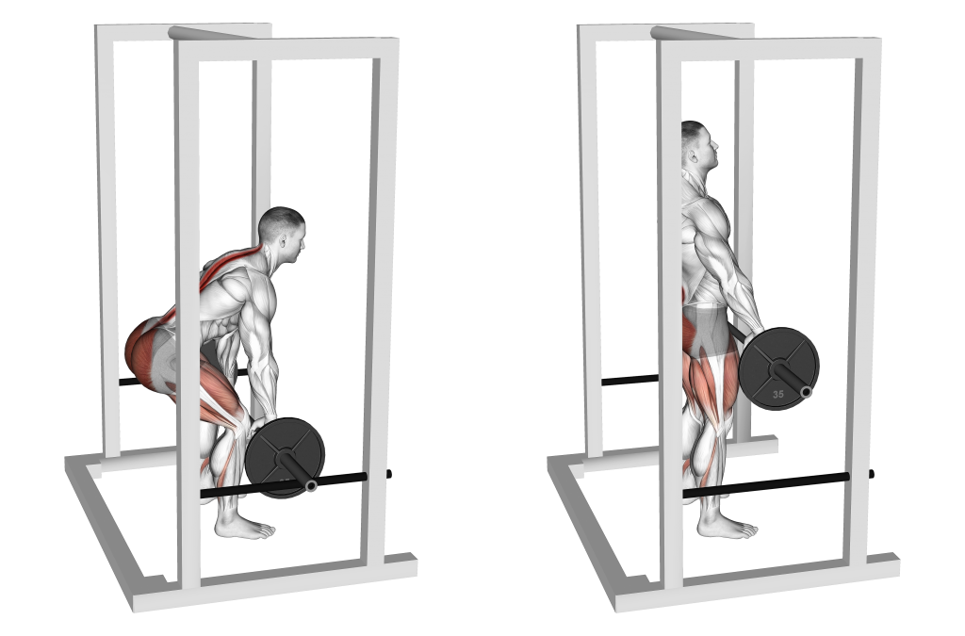
Original source: here
Rack pulls are essentially a conventional deadlift with a partial range of motion. They’re great at replicating the same movement pattern as a conventional deadlift.
To perform this, you’ll need a barbell and a power rack. First, set the height of your rack. The most popular positions tend to be just below the knee, just above it, or halfway up the thigh. The lower the height, the more your glutes and hamstrings will be in focus. The higher the height, the more your back will be used, so choose a height that aligns with whatever your abilities/goals are. When the rack is at the desired height and you’re standing with your feet shoulder width apart, place the bar on it and bend down as you hinge forward at the hips to grasp it. Then hold it with your palms in an overhand grip and your hands also shoulder-width apart. Then, as you pick up the bar, drive your hips forward and straighten your knees. Make sure you don’t make you don’t drive your hip forward too much, as you might lose control and be driven by the momentum of the barbell. Finally, reverse the movement to put the bar back on the rack and repeat.
Since rack pulls are quite similar to conventional barbell deadlifts, they work just about the same muscles such as the hamstrings, glutes, upper back, and your lower back. However, the lower back tends to be the primary muscle targeted with rack pulls. Since it’s very similar to the barbell deadlift, it replicates the hip hinging part of it quite well.

TRAP BAR DEADLIFTS
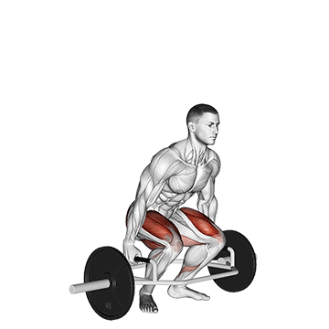
Original source: here
Another brother to the conventional deadlift that tends to work the same muscle groups as it, except you’re gonna need a special kind of bar called a trap bar (or hex bar) for this one. It’s shaped like a trapezoid (hence the name) and you stand inside of it.
To do a trap bar deadlift, start in a feet hip-width apart stance with toes pointed forward. If it helps, your feet should be aligned with the handles, and so should your shoulders. Hinge down to grab the barbell, and then lift it up off of the floor. At this point, you should pause at the top, your shoulders should be down, your pelvis neutral, and the load dispersed evenly throughout your body. Then, go back down and repeat as needed.
This is a great alternative to the deadlift due to the natural and upright position that can limit stress on your lumbar spine. It also helps beginners learn good form so they can move on to barbell deadlifts. In terms of muscles worked, you will find that this move targets your glutes and hamstrings. However, those looking to build their lower back might want to stay away from the trap bar for now, since it’s not the ideal candidate for that.

REVERSE HYPERS
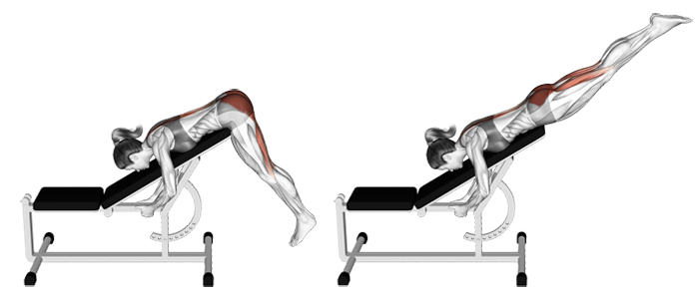
Original source: here
Now, it’s very possible that you may not have heard of this exercise before, but let me tell you what it is and how you can supplement it for a deadlift.
For this exercise, you’ll need to use a special gym machine called a reverse hyper machine. To start, you’ll want to set yourself up at the machine by hooking your feet and putting your front hip crease against the edge of the pad. Flex your glutes to lift your legs up behind you, then let the weight go back down as you relax them. Make sure your legs are in line with your body when they’re lifted. You will also want to arch your back at the top, and then bring it back down in sync with your leg movement.
This move is great for those looking to decompress their spine, as well as build their back and glute strength.
In addition, all of these exercises will help you build your lower body strength and power, and are hip, elbow, wrist, neck, and abdominal pain friendly. They are also all great at working your posterior chain, and all work the same muscle groups as the traditional deadlift.
Phew! Now that we have all those out of the way, we have a good foundation for knowing which moves can help replicate which parts and muscle groups worked of the deadlift. If you want to hit all the muscles the deadlift hits, you will definitely be better off doing more than one of these to sort of ‘fill in the gaps’ that one exercise leaves in those muscle groups. For example, one exercise might work all the desired muscles except the hips, so you’re going to want to add another exercise to your roster that works your hips.
Now we can talk about:

SOME OF THE BENEFITS OF EXERCISES THAT DON’T PUT A LOT OF STRAIN ON THE LOWER BACK
Now this is a bit of a simple question to answer, at least on the surface.
Obviously, the greatest benefit is that they put less stress on your lower back! This can be very useful if your lower back tends to be a problem area for you, which it does tend to be for some people.
However, everything comes at a price, and the price for exercises not putting as much strain on your posterior chain is that you’ll tend to experience very little strengthening in that area. Of course, since that area will experience little to no strain or resistance, it’s very unlikely that you’ll get significantly stronger in that area over time.
Even though that might be a bit of a con, there is another benefit for those exercises, and that is that they tend to in turn put a greater emphasis on other muscles such as your quads, hamstrings and/or glutes. So, in a way, you’re almost compensating for the strength lost in your lower back by the strength gained in other muscles.
So even though you might be losing out on some lower back strength, you definitely won’t have to worry about your quads, hamstrings, or glutes being weak!
Now, maybe lower back pain isn’t your problem, and you’d rather know,

WHAT ARE SOME EXERCISES THAT CAN IMPROVE COORDINATION AND BALANCE
Balance and coordination can definitely be a problem, and even a roadblock for some people. You’ll need some pretty good balance for single-leg Romanian deadlifts.
However, not all is lost, and you’ll soon be able to improve your balance if you dedicate some time to improving the fundamental way you keep your balance and coordinate your body every day. I wrote an article on how to help you do that that can be found here.
So before you go attempting moves that you’re sure will have you ending up on the floor, you should work on improving your fundamental balancing and coordination skills, rather than putting them to the test and pushing through an exercise. Not only could this result in injury, but it could also compromise the proper form and effectiveness of the exercise you’re doing.
Perhaps you’ve already mastered the art of balance and coordination, and you’re facing another issue:

HOW TO EXERCISE IF MOBILITY IS AN ISSUE
Mobility can definitely be an issue with many moves. Mobility is important, and it’s typically not a good thing if you’re restricted in any parts of your movement. This is because all exercises have something called a “range of motion”, and if you want to get the most out of the move, you need to be able to perform the move in its full range of motion.
For example, to get the full range of motion for a squat, you need to go down until your butt touches your heels (or as close to it as you can get). If you don’t go all the way down due to some mobility issue, then you won’t get as much out of the squat as if you had optimal mobility.
Because of that, I strongly suggest improving mobility in conjunction with working on your strength. The fact of the matter is, unless you are 7 feet tall or very overweight to the point of not being able to bend over far enough, you should be able to do a deadlift with little to no issues.
Nevertheless, two exercises that are good if general mobility is a problem are rack pulls and kettlebell swings, since you’re not really taking any muscle to the edge of its range of motion. I detail how to perform all of these earlier in the article.
However, improving mobility should be one of your top priorities if it’s limiting certain movements. If mobility is not a limitation in any movement, then don’t worry about it.
Now, to wrap up and address all kinds of pains/limiting factors in your exercise plan, let’s talk about:

DEADLIFT ALTERNATIVES FOR THOSE WITH BACK, SHOULDER, KNEE, AND GENERAL JOINT PAIN
So let’s address these one at a time.
For back pain, you can try:
- Barbell hip thrusts and trap bar deadlifts for the glutes
- Glute-ham raises and hamstring curls for the hamstrings
- Reverse hypers for the lower back
And if just knee pain is your problem, then don’t worry, because deadlifts are already a knee friendly exercise! However, if you still feel that traditional deadlifts are hurting your knees, then try any of the exercises listed above for back pain.
If just shoulder pain is your problem, then you also don’t have to worry, as deadlifts don’t usually affect the shoulders at all. It’s not an upper body exercise, so there should be very little strain on them. However, if your shoulder is still bothered while doing a classic deadlift, then you can try any of the deadlift alternatives above that don’t use your shoulder, like barbell hip thrusts and hamstring curls.
Now, if general joint pain is your problem, then that’s where it gets a little complicated. Upper body and lower body exercises/alternatives will hurt. You’ll first of all want to address that with some medications, supplements, or any other interventions to lessen the pain.
With general joint pain, just about every exercise for that joint will hurt, unfortunately. However, the question is how much pain you’re willing to put up with. If you are really set on going to the gym and lifting weights, then you might want to figure out if you can tolerate a small increase in pain for a while. As long as the exercise(s) doesn’t make the pain unbearable or worse over time, then it really is a question of how much you can handle, and if you’re willing to handle it.
However, my biggest advice is really to address that pain through other means first.
All of this may seem very difficult to sift through at first, and maybe you are scared of picking the wrong exercise which may end up making your pain worse. In that case, we should discuss:

WHEN TO INVOLVE A PROFESSIONAL
In my opinion, there are typically 3 reasons people choose to involve professionals, such as personal trainers. These 3 reasons are:
- Speed
- Safety
- Accountability
People tend to want results, and they want to see them fast. It’s all about losing those 15 pounds of fat in a week (extremely unhealthy, by the way), getting the biggest muscles in a month, or being able to bench 250 pounds by next Thursday.
However, by doing the things they think will get them to their goal faster, people end up putting themselves into ruts, where they’re just running in a circle and getting nowhere, as well as stalling their progress.
In the time that a person could have spent doing the wrong things in the gym, and not following the right diet for them, someone with a personal trainer could have gone really far, and progressed a lot. Because of that, people tend to see personal trainers as paragons of speed. Don’t get confused, however, you won’t achieve that 15 pound weight loss in a week with a personal trainer, but you’ll definitely get there a little quicker than someone who may be wasting time on quick fixes, or trial and error.
In short, a good personal trainer has experience, and knows what to tweak when things aren’t moving along as they should be to get them back on the right track.
In terms of safety, there are right ways to do some exercises, as well as wrong ways. Doing certain moves without the right technique for you, or proper form can easily injure you, or just cause you to not see any progress. It sort of puts you in this false state of mind where you think you’ve been working hard and you’re seeing nothing in terms of results, which is definitely discouraging and frustrating.
However, experienced personal trainers are great for that because they know what proper form is, and how to make sure you are doing your exercise correctly. Plus, they can help prevent injury by stopping you when you want to try lifting 300 pounds, when you could barely hold up a 20 pound dumbbell just last week. However, in the event that you do feel prepared to lift a really heavy weight, personal trainers are also great spotters, to make sure you don’t hurt yourself and you perform your exercise correctly.
Accountability tends to be a large issue for many people. A personal trainer can help with accountability because now, you have someone monitoring what you do to make sure you stay consistent. We all know that consistency is the key to making any changes to your body, and personal trainers can help you do just that; be consistent.
In fact, many trainers tend to have a cancellation fee, so you have to pay if you want to cancel a gym session. I’m sure many people would rather just get up and go to the gym rather than pay to not go.
Of course not everyone has the luxury of a personal trainer to help them stay safe while they’re exercising, let’s talk about:

TIPS FOR AVOIDING INJURY WHEN EXERCISING
This is a bit of a difficult topic to cover as a small part of this article, as it can be an article on its own (and indeed, I’ve written a bunch of articles on both injury avoidance, and rehabilitation). This is really general and will be different for literally everyone. However, a couple things you could take into account, without going into too much detail, is making sure you have good technique, good mechanics, a good ratio of quad to hamstring activation, and making sure you don’t flex at the spine.

DEADLIFT ALTERNATIVES – THE BOTTOM LINE
So, the very bottom line of deadlifts is that if you can do them without any issues, then you should! They’re a great compound movement that targets a good chunk of your lower body in one go, and they’re great at building strength in those areas, as well as in general. Essentially, try not to neglect your technique and dedication to this move.
On the flip side, since the deadlift spreads the load to whichever muscles are most suited for it, you’ll also want to add other exercises to your strength training routine that are underworked by the deadlift.
For example, deadlifts do work your quads, sure, but not as well as a squat or a leg press does.
However, if you have any condition or pain that prevents you from performing a deadlift without discomfort, then you should try to fill in the gap that a deadlift would leave in your workout with alternatives that target the same muscles as the deadlift does.
To put it simply, not a single exercise is on its own good or bad, it’s all about how you use it, and how you incorporate it into your routine.

